Praise for Magdalena Filipczak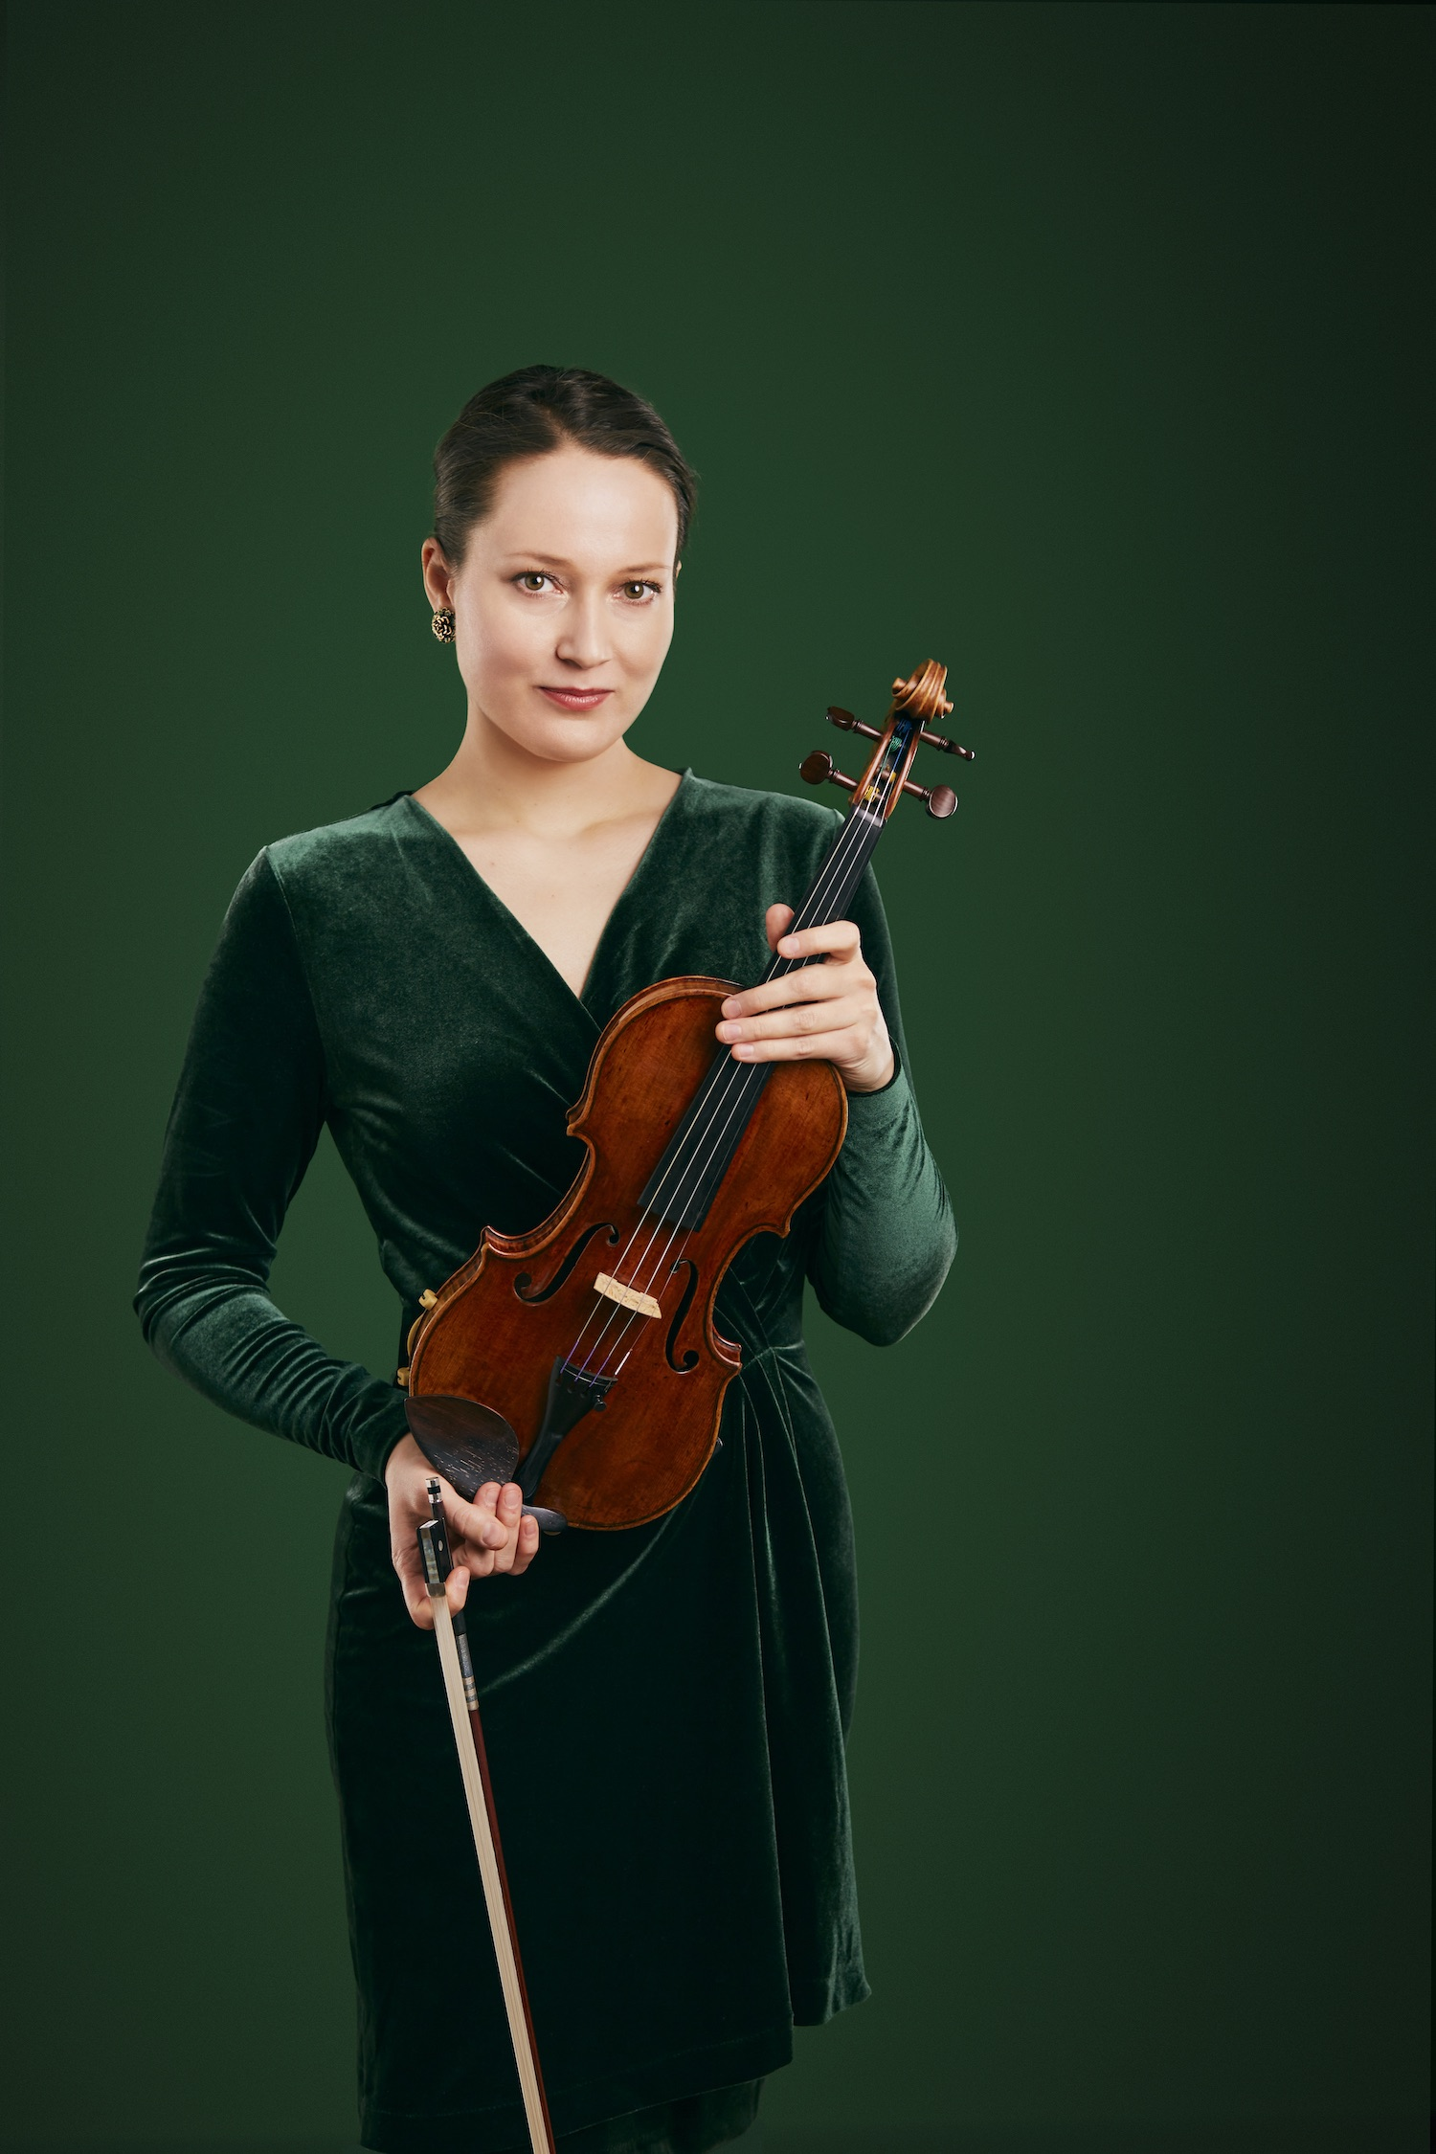

“it was a concert not to be forgotten…Ms. Filipczak exploited it as the vehicle of violin wizardry it was meant to be, showing a huge emotional range from violent outbursts to lyrical lines…surpassed expectations”

*Rorianne Schrade, New York Concert Review*

“Not many solo recitals are as eclectic as this...She's a musical chameleon, quickly getting under the skin of whatever she's playing”

*Graham Rickson, The Arts Desk*

“Virtuosic music making of the highest order”   
*Dave Robson, The Darlington and Stockton Times*

“Performance full of humanity and empathy”  
*George Grella, New York Classical Review*

“Icily capricious runs and howling high notes reflected not just of the virtuosity of a professional but the hunger and earnestness of youth.”

*Jimmy Brewer, Cherwell*

“This talent was evident. She led the players behind her admirably... The echoes and trills in the Allegro of *Spring* were well controlled, and the famous semiquaver broken chords from Filipczak were spotless, as were her rapid descending scales in the Presto of *Summer*. In the Allegro of *Autumn* the runs were impeccably timed against the orchestra’s pulse, and the Largo in *Winter* had an elegant and lyrical sequential melody.”

*Billie Hylton, Bach Track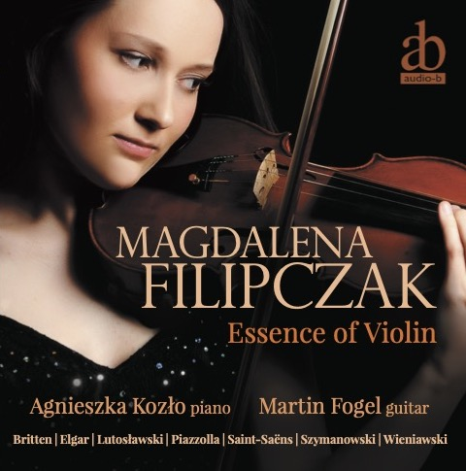*

On her debut CD Essence of Violin:

“glittering...beguiling...captivating...hauntingly atmospheric...”

*Julian Haylock, The Strad*

Listen on Spotify: [CLICK HERE](https://open.spotify.com/album/4Hfb3CPpuR6tyWhRl7KXdS?si=ZHS54XAARtOivIQ32pzcRQ)

Download high quality CD audio (dropbox link):[CLICK HERE](https://www.dropbox.com/home/Debut%20CD)

Website: [http://www.magdalenafilipczak.com](http://www.magdalenafilipczak.com/)  
YouTube: <https://www.youtube.com/theviolinm>

Facebook: <https://m.facebook.com/MagdalenaFilipczakViolinist>

Instagram: <https://www.instagram.com/magdalena.filipczak/>

Violinist Magdalena Filipczak has been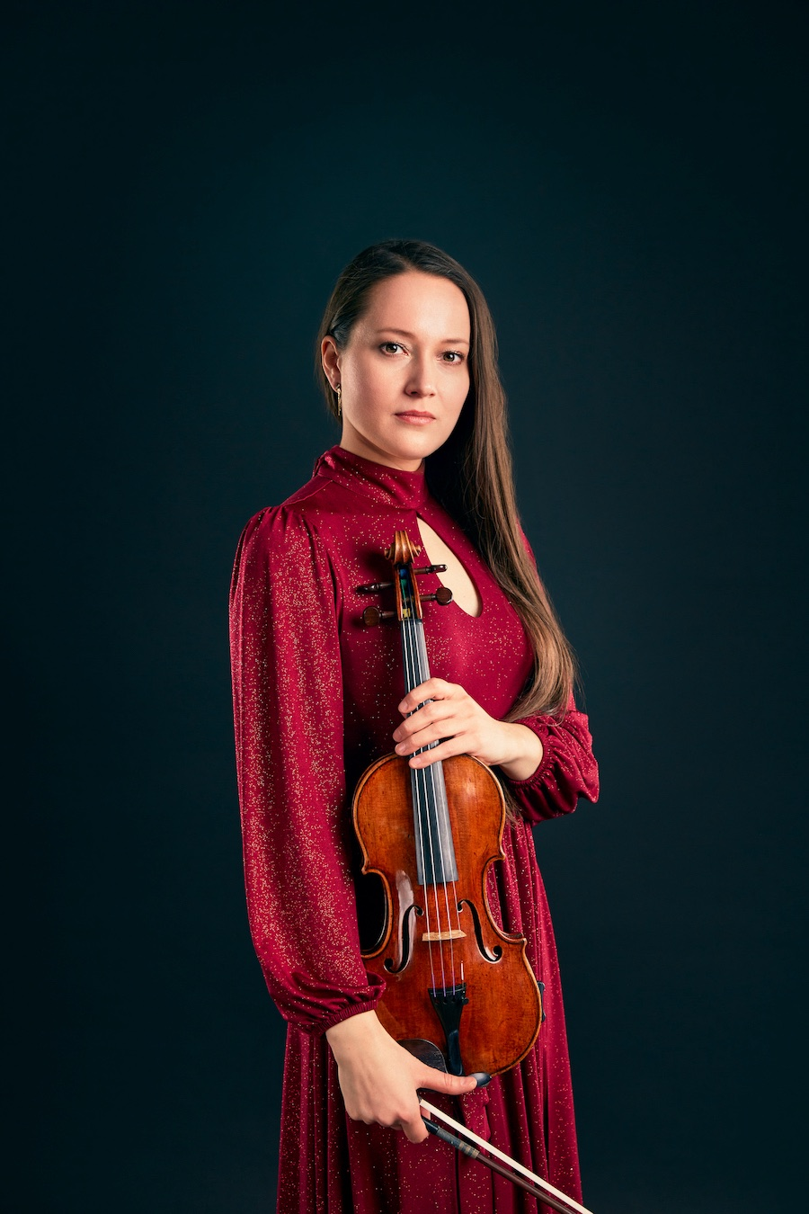 praised as “a musical chameleon, quickly getting under the skin of whatever she’s playing” (THE ARTS DESK), with a flair for captivating performances that leave a lasting impression. Her recent Carnegie Hall recital debut was heralded by the New York Concert Review as “a concert not to be forgotten…Ms. Filipczak exploited it as the vehicle of violin wizardry it was meant to be…surpassed expectations.”

With her eclectic and extensive repertoire she has appeared as a soloist, recitalist, and chamber musician at the stages of some of the world’s most prestigious venues, including Wigmore Hall, Barbican Hall, St John’s Smith Square in London, Het Concertgebouw in Amsterdam, Tallinn Philharmonic in Estonia, Cracow Philharmonic, the Baltic Philharmonic in Poland, and Carnegie Hall in New York. She has performed throughout Europe, in North and South America, and Canada, entrancing audiences with her emotional depth and technical brilliance. Since 2022, Magdalena has been collaborating as a soloist with the International Conducting Academy (ICA) in London.

Among Magdalena’s many international competition successes, she is the winner of the IV Heino Eller International Violin Competition in Estonia, and recipient of special prizes for the best interpretation of Bach (Bärenreiter Edition Prize), and the best concerto performance (Music Academy in Tallinn Prize). Most recent honours include Gold Prize of 2018 Manhattan International Music Competition, Silver Prize at 2018 Berliner International Music Competition, and First Prize at 2017 United States International Concerto Competition. For her achievements, and contributions to the culture, she was awarded Młoda Polska Scholarship by the Polish Ministry of Culture and National Heritage.

Magdalena's critically acclaimed debut solo CD, Essence of Violin, was celebrated by THE STRAD Magazine as “glittering…beguiling…captivating…hauntingly atmospheric.” Her upcoming release with the renowned Hungarian pianist Peter Frankl promises to be a significant addition to her discography, and her new recordings with her brother, pianist Lukasz Filipczak, on the legendary ex-Ida Haendel Stradivari, will soon be released as an EP. Magdalena's violin solos for the recent BBC TV and podcast series "Thief at The British Museum" further highlight her versatility and reach. She has also featured in two albums with music by Grammy Award composer and saxophonist Tim Garland, *Songs to the North Sky* and *Weather Walker,* two CDs with music by Peter Gregson, Quartets: One and Quartets: Two, released on Deutsche Grammophon, and two disks recorded with Gruppo Montebello at the Banff Arts Centre in Canada featuring the Second Viennese School composers.

Magdalena’s performances have been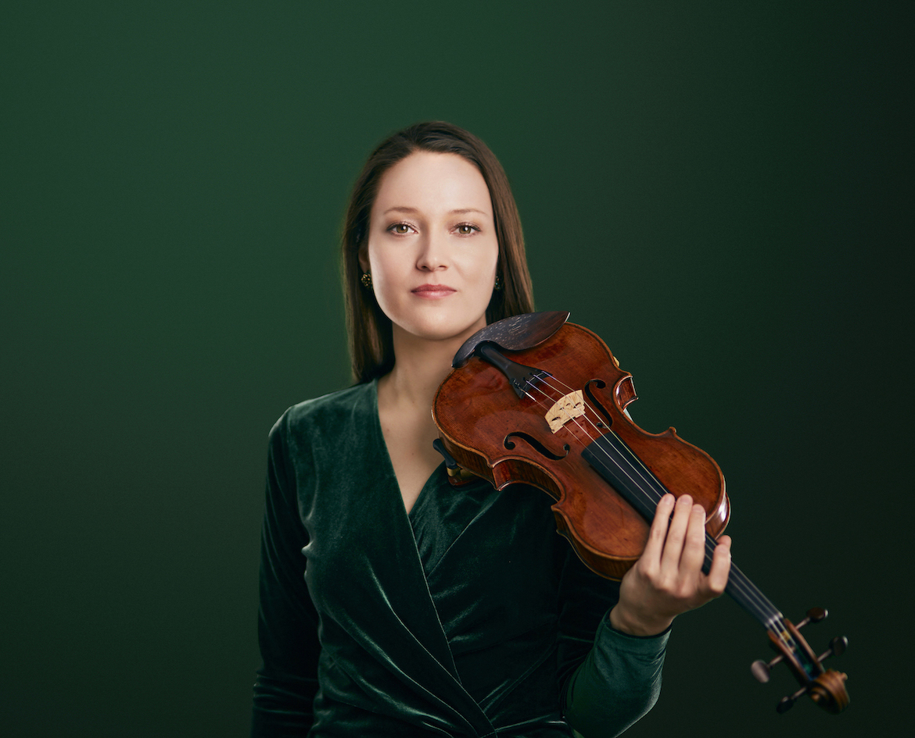 broadcast on BBC Radio 3, Chicago WFMT Radio, Dutch Radio 4, Canadian Radio, Bulgarian TV, and Polish, Austrian, and Estonian TV and Radio. She has also toured Brazil and Argentina as a guest leader/director with the Tallinn Chamber Orchestra showcasing her dynamic leadership.

Magdalena is a graduate of The Perlman Music Program founded by the renowned violinist Itzhak Perlman. She joined the program in 2017 as one of the few violinists in the program’s history from outside Juilliard School and Perlman’s own studio. Magdalena was also one of the musicians selected for the Tour of New Masters by The Holland Music Sessions. During a musical residency at the Banff Arts Center in Canada, she premiered a new violin crafted by the famous American luthier Samuel Zygmuntowicz. The instrument, commissioned by the Banff Arts Center, was debuted during a live radio performance just hours after its delivery.

Festivals appearances include Proms (UK), City of London Festival (UK), Edinburgh Fringe Festival (Scotland), the Perlman Chamber Music Festival (USA), Yellow Barn (USA), Krzyżowa-Music (Poland), Ryedale Festival (UK), Brundibár Arts Festival (UK), Swaledale Festival (UK), Norfolk Festival (USA), Paxos Chamber Music Festival (Greece), Lidköping Festival (Sweden), Tudeley Festival of Chamber Music and Voice (UK), Tallinn Chamber Music Festival (Estonia), IMS Prussia Cove (UK).

After graduating from the Guildhall School of Music and Drama in London, where she studied with the distinguished Polish violinist Krzysztof Smietana, she was awarded an Individual Artist’s Fellowship. At the Guildhall she won the Max and Peggy Morgan Violin Concerto Prize, and together with Filipczak Piano Trio the Ivan Sutton Chamber Music Award of the City Music Society in London. Magdalena also trained voice at the Guildhall with John Evans and later she had private lessons with Benita Valente in America. Currently she is a recipient of the prestigious Fellowship Award of CUNY Graduate Center in New York for Doctoral Studies in Music Performance where she is writing a performance guide to Britten’s Violin Concerto. During DMA she had been mentored by Daniel Phillips and Donald Weilerstein on the violin, and additionally she trained voice with Robert White.

Magdalena’s musical excellence has been recognised through numerous prestigious scholarships, including the Musicians’ Benevolent Fund, the Philharmonia Orchestra/Martin Musical Scholarship Fund, the Craxton Memorial Trust, the City of London Corporation, the Derek Butler Trust, the Wolfson Foundation, the English Speaking Union, the Norfolk Festival/ Yale Summer Music School Fellowship, the Fishmongers’ Company, the Solti Foundation, and the Zetland Foundation.

Beyond her performance career, Magdalena is an inspiring educator, having taught at the City University and Trinity Laban Conservatoire of Music and Dance (Junior Department) in London, and the Aaron Copland School of Music (Queens College/CUNY) in New York. She has given masterclasses in Brazil, Yellow Barn’s Young Artists Program, and through Itzhak Perlman’s Music Residencies in America, sharing her passion and expertise with the next generation of musicians.

Since 2019 she is supported by the Beare’s International Violin Society in London which kindly loans Magdalena some of the finest instruments, including violins by Stradivarius, Nicolo Amati, Guadagnini, Francesco Rugeri or Peter Guarneri.

Press Contact

**Email:** [magdaviolinist@gmail.com](mailto:magdaviolinist@gmail.com)

+44 7828180642 (also WhatsApp)