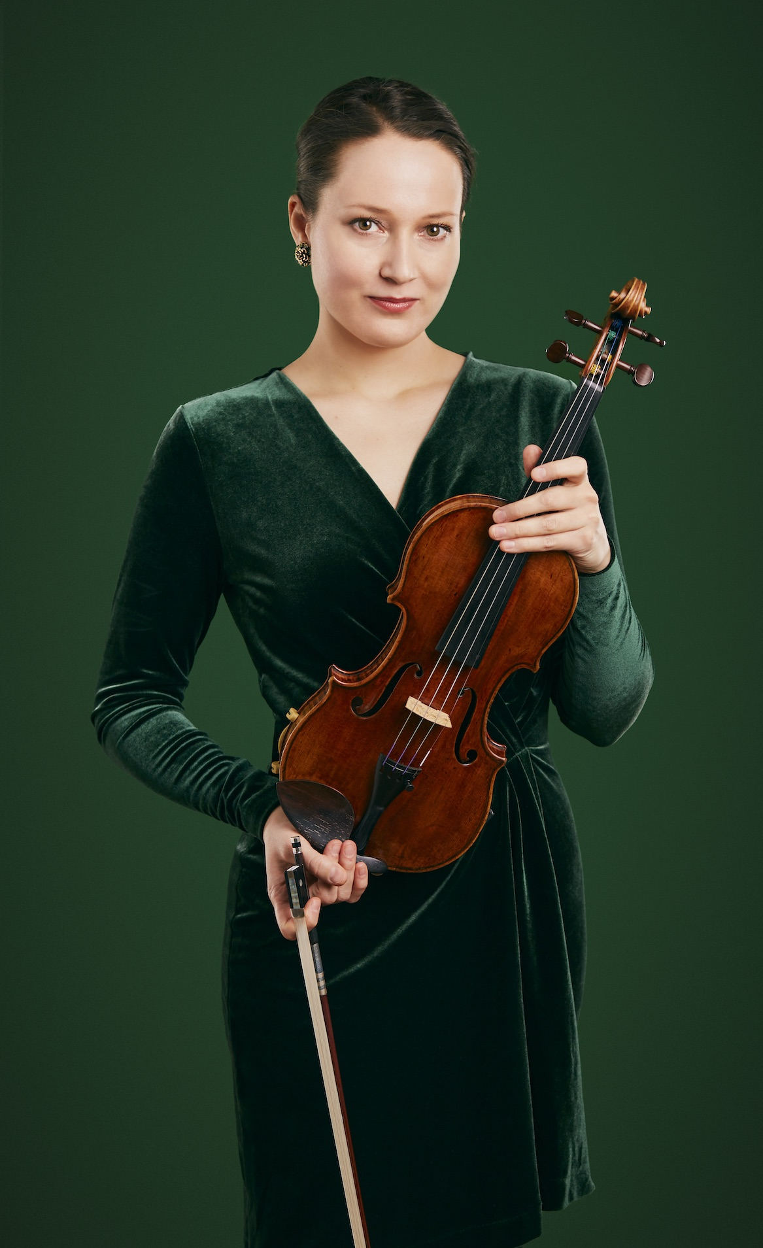
Praise for Magdalena Filipczak
“it was a concert not to be forgotten…Ms. Filipczak exploited it as the vehicle of violin wizardry it was meant to be, showing a huge emotional range from violent outbursts to lyrical lines…surpassed expectations”
Rorianne Schrade, New York Concert Review

“Not many solo recitals are as eclectic as this...She's a musical chameleon, quickly getting under the skin of whatever she's playing”
Graham Rickson, The Arts Desk

“Virtuosic music making of the highest order”
Dave Robson, The Darlington and Stockton Times

“Performance full of humanity and empathy”
George Grella, New York Classical Review

“Icily capricious runs and howling high notes reflected not just of the virtuosity of a professional but the hunger and earnestness of youth.”
Jimmy Brewer, Cherwell

“This talent was evident. She led the players behind her admirably... The echoes and trills in the Allegro of Spring were well controlled, and the famous semiquaver broken chords from Filipczak were spotless, as were her rapid descending scales in the Presto of Summer. In the Allegro of Autumn the runs were impeccably timed against the orchestra’s pulse, and the Largo in Winter had an elegant and lyrical sequential melody.”
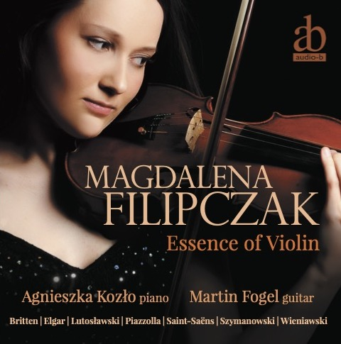
Billie Hylton, Bach Track
On her debut CD Essence of Violin:

“glittering...beguiling...captivating...hauntingly atmospheric...”
Julian Haylock, The Strad

Listen on Spotify: CLICK HERE
Download high quality CD audio (dropbox link): CLICK HERE
Website: http://www.magdalenafilipczak.com
YouTube: https://www.youtube.com/theviolinm
Facebook: https://m.facebook.com/MagdalenaFilipczakViolinist
Instagram: https://www.instagram.com/magdalena.filipczak/
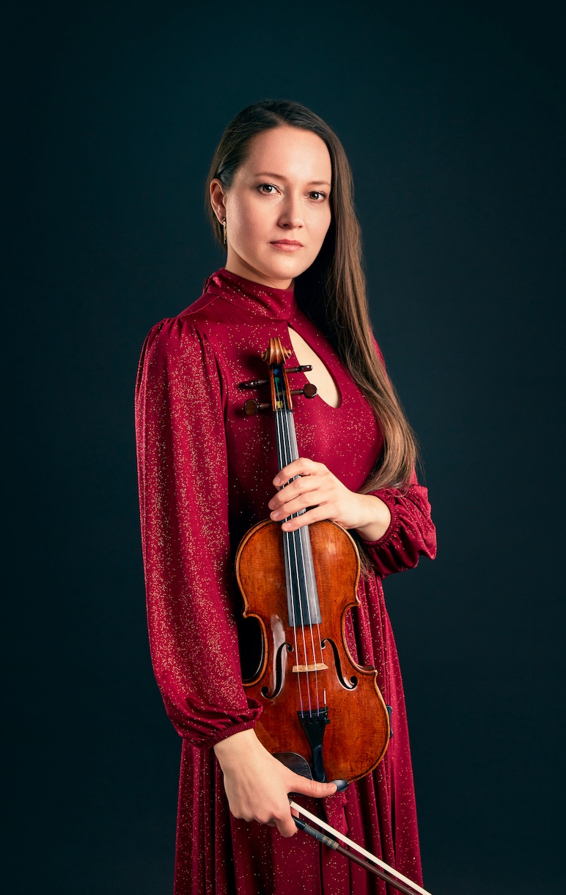
“It was a concert not to be forgotten…Ms. Filipczak exploited it as the vehicle of violin wizardry it was meant to be…surpassed expectations” wrote the New York Concert Review about the recent Carnegie Hall recital debut of award-winning violinist Magdalena Filipczak.

The ARTS DESK described her as “a musical chameleon, quickly getting under the skin of whatever she’s playing”.

With her eclectic and extensive repertoire she has appeared as a soloist and chamber musician in the UK (including Wigmore Hall, Barbican Hall, St John’s Smith Square), in Europe (among others in Het Concertgebouw, Tallinn Philharmonic, Cracow Philharmonic, Baltic Philharmonic) as well as in the USA (Carnegie Hall), Canada and South America.
Among her many international competition successes, she is the winner of the IV Heino Eller International Violin Competition in Estonia and recipient of special prizes for the best interpretation of Bach (Bärenreiter Edition Prize) and the best concerto performance (Music Academy in Tallinn Prize). Most recently Magdalena has received Gold Prize of 2018 Manhattan International Music Competition, Silver Prize at 2018 Berliner International Music Competition, and First Prize at 2017 United States International Concerto Competition. For her achievement she was awarded Młoda Polska Scholarship (Young Poland) by the Polish Ministry of Culture and National Heritage.
Magdalena’s new CD with a renowned Hungarian pianist Peter Frankl is in the final stage of postproduction. Her solo debut CD Essence of Violin has been praised by critics, including THE STRAD Magazine as “glittering…beguiling…captivating…hauntingly atmospheric…”.
Recently she has been producing and publishing on YouTube her new recordings recoded on ex-Ida Haendel Stradivari with her brother, pianist Lukasz Filipczak, which will be later released as EP. Magdalena has also featured in two albums with music by Grammy Award composer Tim Garland, Songs to the North Sky and Weather Walker, two CDs with music by Peter Gregson, Quartets: One and Quartets: Two, recently released on Deutsche Grammophon, and two disks recorded with Gruppo Montebello at the Banff Arts Centre in Canada featuring the Second Viennese School composers.
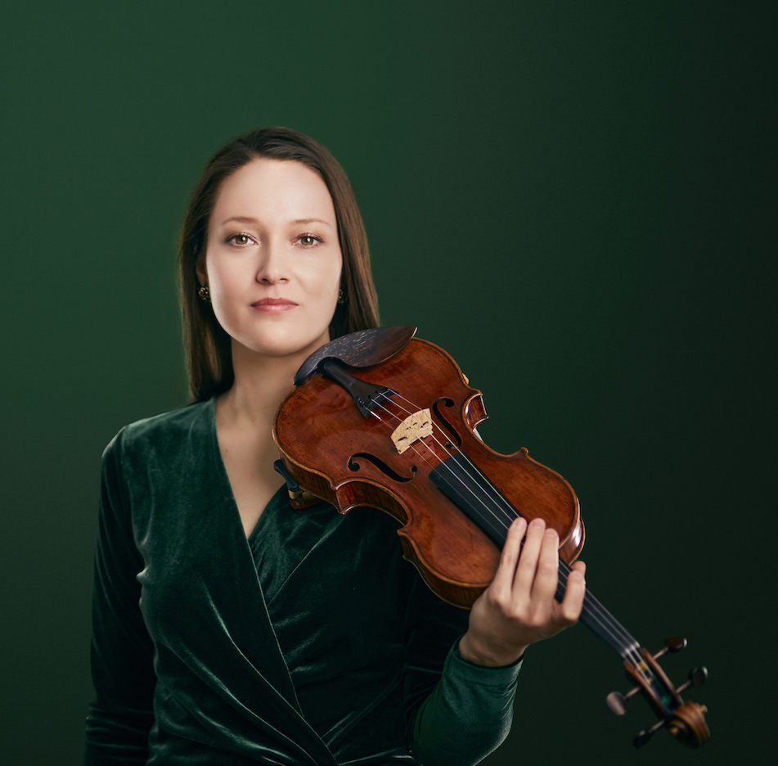
Media appearances include BBC Radio 3, Chicago WFMT Radio, Dutch Radio 4, Canadian Radio, Bulgarian TV, Polish, Austrian and Estonian TV and Radio. Magdalena also toured Brazil and Argentina as a guest leader/director with the Tallinn Chamber Orchestra.
Magdalena was one of the Holland Music Sessions’ New Masters on Tour, and she was admitted and performed at American music training programs, including Itzhak Perlman Chamber Music Program and Residencies, Yellow Barn, Norfolk Festival, as well as Krzyżowa-Music in Poland, and IMS Prussia Cove in the UK.
After graduating from the Guildhall School of Music and Drama in London, where she studied with the distinguished Polish violinist Krzysztof Smietana, she was awarded an Individual Artist’s Fellowship. At the Guildhall she won the Max and Peggy Morgan Violin Concerto Prize, and together with Filipczak Piano Trio the Ivan Sutton Chamber Music Award of the City Music Society in London. Magdalena also trained voice at the Guildhall with John Evans and later she had private lessons with Benita Valente in America. Currently she is a recipient of the prestigious Fellowship Award of CUNY Graduate Center in New York for Doctoral Studies in Music Performance. During DMA she had been mentored by Daniel Phillips and Donald Weilerstein on the violin, and additionally she trained voice with Robert White.
Magdalena has been awarded scholarships from the Musicians’ Benevolent Fund, the Philharmonia Orchestra/Martin Musical Scholarship Fund, the Craxton Memorial Trust, the City of London Corporation, the Derek Butler Trust, the Wolfson Foundation, the English Speaking Union, the Norfolk Festival/ Yale Summer Music School Fellowship, the Fishmongers’ Company, the Solti Foundation and the Zetland Foundation.
Magdalena is also an avid music educator. She has taught in London at the City University and Trinity Laban Conservatoire of Music and Dance (Junior Department), and in New York at the Aaron Copland School of Music (Queens College/CUNY). She has given masterclasses in Brazil, Yellow Barn’s Young Artists Program and through Itzhak Perlman’s Music Residencies in America.
Since 2019 she is supported by the Beare’s International Violin Society in London which kindly loans Magdalena some of the finest instruments, including violins by Stradivarius, Nicolo Amati, Guadagnini, Francesco Rugeri or Peter Guarneri.
Press Contact
Email: magdaviolinist@gmail.com
+44 7828180642 (also WhatsApp)

